Requirements Engineering Artifact

An overview of the emails exchanged with the TA before we began Project 3 is given below.

**From:** Shah, Tanishka <tanishah2001@ku.edu>

**Sent:** Thursday, March 18, 2021 12:11 AM

**To:** Boddi Reddy, Sushmitha <s871b370@ku.edu>; Niang-Trost, Tevin Terrel <tniangtrost@ku.edu>

**Cc:** Johnson, David Orville <davidojohnson@ku.edu>; Widman, Kai C <kcwidman@ku.edu>; Newman, Robert J <rjnew04@ku.edu>; Kandaswamy, Sandhya <sandhya@ku.edu>; Suresh, Charan <charan_s@ku.edu>

**Subject:** EECS 448 Project 3 & 4 Plans

Hello,

This is Tanishka from Team 8. In this email we would like to explain our ideas for Project 3 and how we plan on scaling it up for Project 4.

Project 3:

We plan to make a game similar to flappy bird, coded in Python, using python modules like Pygame.

Project 4:

We plan to scale up the game by adding various features to it.

Some examples of features we could add are: More levels to the game, Sound effects, Super Powers and many more.

Please let us know if you approve of this project and we can start building the game.

Thank you,

Tanishka Shah and Team 8

______________________________________________________________________

**From:** Niang-Trost, Tevin Terrel <tniangtrost@ku.edu>

**Sent:** Friday, March 19, 2021 10:45 AM

**To:** Shah, Tanishka <tanishah2001@ku.edu>; Boddi Reddy, Sushmitha <s871b370@ku.edu>

**Cc:** Johnson, David Orville <davidojohnson@ku.edu>; Widman, Kai C <kcwidman@ku.edu>; Newman, Robert J <rjnew04@ku.edu>; Kandaswamy, Sandhya <sandhya@ku.edu>; Suresh, Charan <charan_s@ku.edu>

**Subject:** RE: EECS 448 Project 3 & 4 Plans

Hi Tanishka,

I’d like to know a little more about your plans for Project 3. I like your ideas for scaling it up for Project 4. I’m just curious about if you have enough planned for Project 3.

Tevin

______________________________________________________________________

**From:** Shah, Tanishka <tanishah2001@ku.edu>

**Sent:** Friday, March 19, 2021 11:10 AM

**To:** Niang-Trost, Tevin Terrel <tniangtrost@ku.edu>

**Subject:** RE: EECS 448 Project 3 & 4 Plans

Hello!

For Project 3, we plan on recreating flappy bird, and getting started on the framework that we will use to build levels in Project 4. This framework will not be complete by the end of Project 3, as that is not our goal, but we will get started on building it to make it easier to complete as part of Project 4.

For project 4, there are a lot of features that we can implement like coins for powerups and other characters, in addition to what was discussed previously. A majority of the features mentioned will be implemented, but not all.

Tanishka Shah and Team 8

______________________________________________________________________

**From:** Niang-Trost, Tevin Terrel <tniangtrost@ku.edu>

**Sent:** Friday, March 19, 2021 4:04 PM

**To:** Shah, Tanishka <tanishah2001@ku.edu>

**Subject:** RE: EECS 448 Project 3 & 4 Plans

Thanks, Tanishka. Your team can go ahead.

Tevin

Behavioural Requirements

On receiving permission to go ahead and build flappy bird, we decided on the following requirements to begin coding.

Collection of Features:

|  |  |  |
| --- | --- | --- |
| * Start the game * Display each screen properly * Call functions from other classes as needed * Space starts the game * Score is updated after every pipe * Space bar jumps the bird once game starts * Pipes appear randomly once game starts * Start screen with “PRESS SPACE TO START” text * End screen with score, “GAME OVER” text and “PRESS SPACE TO START AGAIN” * Score is displayed on screen * Game ends when bird collides with pipe * Game ends if bird touches the bottom boundary * Bird has flapping wings * Bird rotates upon jumping * Bird keeps falling and does not stay stationary * Scroll background * Display background |  | Game:   * Start the game * Display each screen properly * Call functions from other classes as needed * Space starts the game   Bird:   * Bird has flapping wings * Bird rotates upon jumping * Bird keeps falling and does not stay stationary * Space bar jumps the bird once game starts   Pipes:   * Pipes appear randomly once game starts * Game ends when bird collides with pipe * Game ends if bird touches the bottom boundary * Score is updated after every pipe   Score:   * Start screen with “PRESS SPACE TO START” text * End screen with score, “GAME OVER” text and “PRESS SPACE TO START AGAIN” * Score is displayed on screen   Background:   * Scroll background * Display background |

User Interface Model:

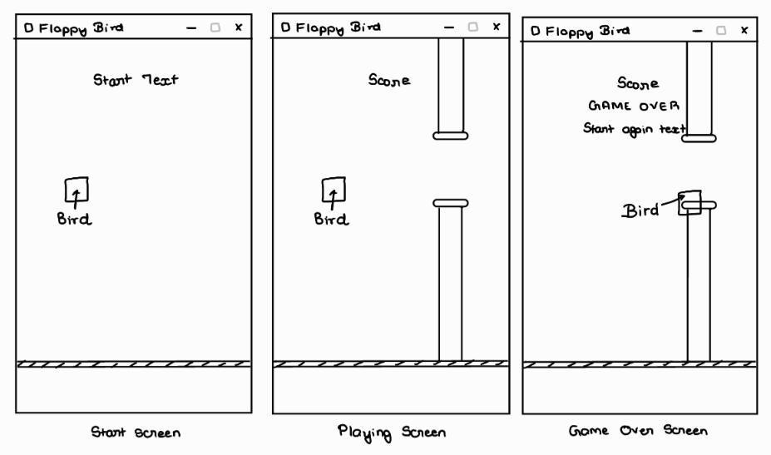

Non - behavioural Requirements

Documentation:

* Requirements Engineering Artifact
* Estimated Number of Hours
* Daily Time Sheet
* Design Paradigms
* Software Architecture
* UML Modeling Diagram
* Design Patterns
* Works Cited